10.94: a), g)
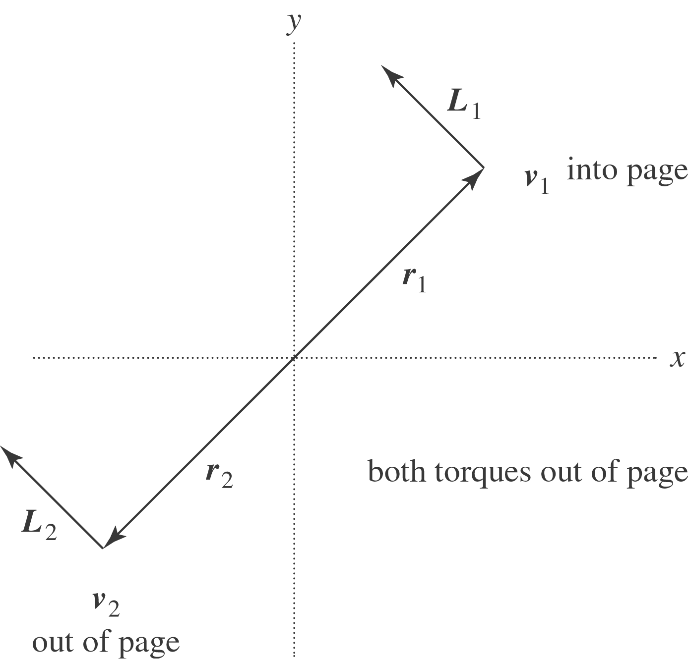

b) Using the vector product form for the angular momentum, 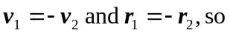

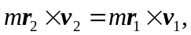
so the angular momenta are the same. c) Let 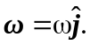Then,
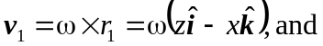

With 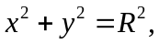 the magnitude of 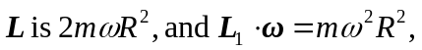and so 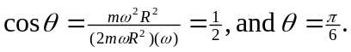 This is true for 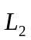as well, so the total angular momentum makes an angle of with the +y-axis. d) From the intermediate calculation of part (c), 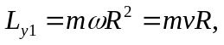 so the total y-component of angular momentum is 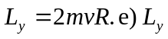is constant, so the net y-component of torque is zero. f) Each particle moves in a circle of radius R with speed v, and so is subject to an inward force of magnitude 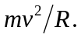 The lever arm of this force is R, so the torque on each has magnitude 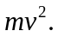 These forces are directed in opposite directions for the two particles, and the position vectors are opposite each other, so the torques have the same magnitude and direction, and the net torque has magnitude 

